

***Progressive Education Society’s***

***MODERN COLLEGE OF ARTS, SCIENCE AND COMMERCE***

***GANESHKHIND, PUNE – 411016***

**A PROJECT ON:**

**Image Encryption**

**SUBMITTED TO:**

**Savitribai Phule Pune University**

**BY:**

**Sanskruti Joshi (223321018)**

**Priyanka Rout (223321060)**

**S.Y BSc (Computer Science) [2022-23]**



***Progressive Education Society’s***

***MODERN COLLEGE OF ARTS, SCIENCE AND COMMERCE***

***GANESHKHIND, PUNE – 411016***

**CERTIFICATE**

This is to certify that **Sanskruti Joshi** and **Priyanka Rout** of **SY BSC (Computer Science)** completed the project work titled **“Image Encryption”** for the curriculum of Savitribai Phule Pune University during the academic year **2022-2023.**

**Project Guide Head of Department**

Prof. Pooja Bahirat Dr. Shubhangi Bhatambrekar

**INDEX**

|  |  |
| --- | --- |
| **Sr. No** | **Name of the Topic** |
| **1.** | **Introduction** |
|  | 1.1 Problem definition |
|  | 1.2 Scope of the Proposed system |
|  | 1.3 Objectives of System |
|  | 1.4 System Requirements |
|  | 1.5 Module Specifications |
| **2.** | **Analysis & Design** |
|  | 2.1 Entity Relation Diagram |
|  | 2.2 Use Case Diagram |
|  | 2.3 Class Diagram |
|  | 2.4 Object Diagram |
|  | 2.5 Sequence Diagram |
|  | 2.6 State Chart Diagram |
|  | 2.7 Activity Diagram |
|  | 2.8 Collaboration Diagram |
|  | 2.9 Component Diagram |
|  | 2.10 Deployment Diagram |
| **3.** | **Pros and Cons** |
| **4.** | **Bibliography** |

**Problem Definition**

The whole world is going through a lot of cybercrimes like hacking of personal information which includes private photos, important data, bank details, forensic investigation etc. The sole purpose of this project is to provide user friendly software to the customer to secure their essential images using methods like Encryption and Decryption. If the images are not encrypted properly someone might get access to the images without any real trouble provided, they have access to wherever the image is being stored. In the 21st century, images are very crucial. Securing data between different endpoints is very important not only for public networks but also for private ones. Data breaches of sensitive, unencrypted information occur almost weekly and many of the events become highly publicized.

Hence, there are many existing systems of image encryption techniques; however, they have certain limitations, such as:

1. Requires large data size

2. Long computational time

3. High computing power

4. Unsuitable for practical image encryption and online communication.

**Scope Of the Proposed System**

The conventional cryptographic algorithms are mainly based on discrete mathematics. Chaos-based cryptography relies on the complex dynamics of nonlinear systems.

The image encryption algorithm includes 2 steps:

1. Firstly, the image fusion is completed between the original image and the key image.
2. The pixel values of the fusion image are encrypted by the Henon chaotic system.

Chaos-based image encryption systems are also fast enough for real-time applications.

**Objectives**

The purpose of Encryption is confidentiality-concealing the content of the message by translating it into a code. Encryption process includes verification of the sender’s image and indicates that the content has not been changed.

The conversion of an encrypted image into its original form is Decryption. It is generally a reverse process of encryption. It decodes the encrypted information so that an authorized user can only decrypt the data as decryption requires a secret key or password.

Provide an image encryption mechanism which provides high security level, less computational time and power in a reliable and efficient way to deal with bulky, difficult and intractable data.

**System Requirements**

**Hardware requirements:**

Processor: Pentium IV 2.0 GHz and above

Hard disk: 10GB

RAM: 256 MB

**Software requirements:**

Operating system: Windows

IDE: MyEclipse

Coding language: Java

**Front end:** J2EE

**Back end:** MySQL

**Module Specifications**

**Encryption:**

· Selects image

· Provides key for encrypting

**Decryption:**

· Key for decrypting

· Gives original image

**User:**

· Create account

· Log in to the account

· Upload or download image

**Entity Relation Diagram**

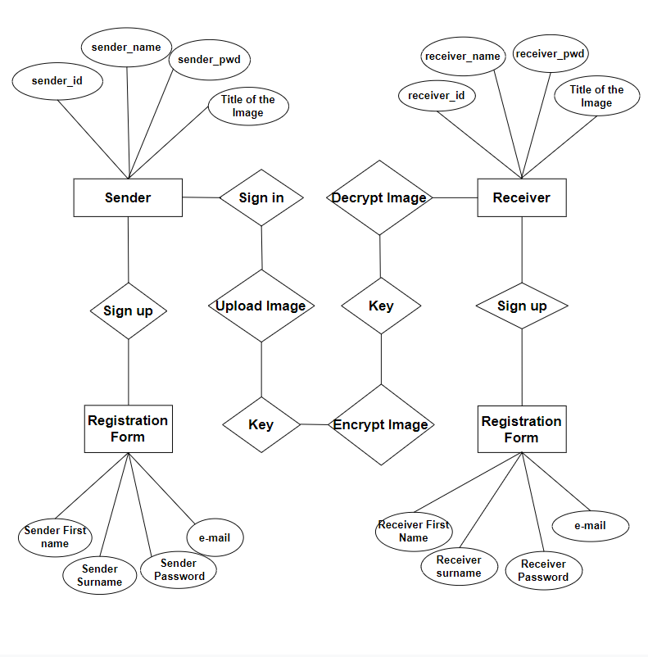

**Use Case Diagram**

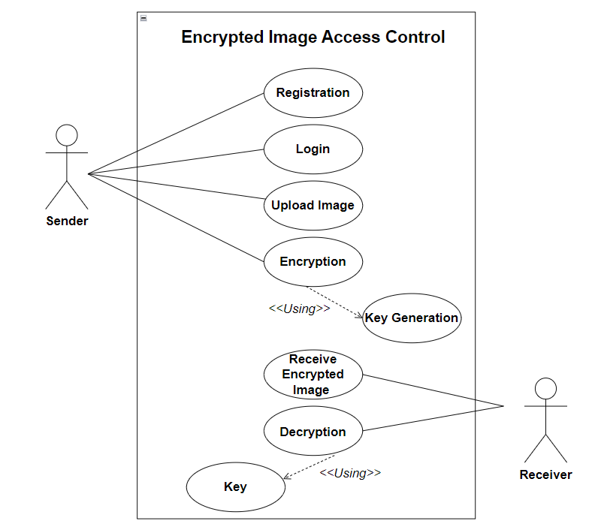

Class Diagram

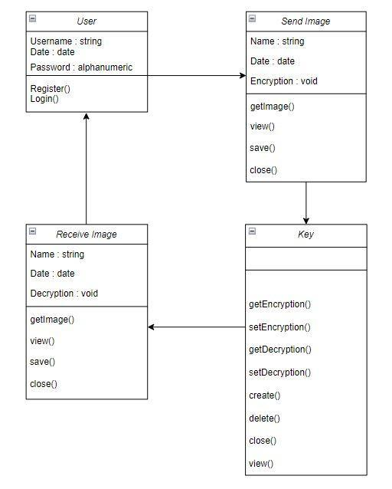

Object Diagram

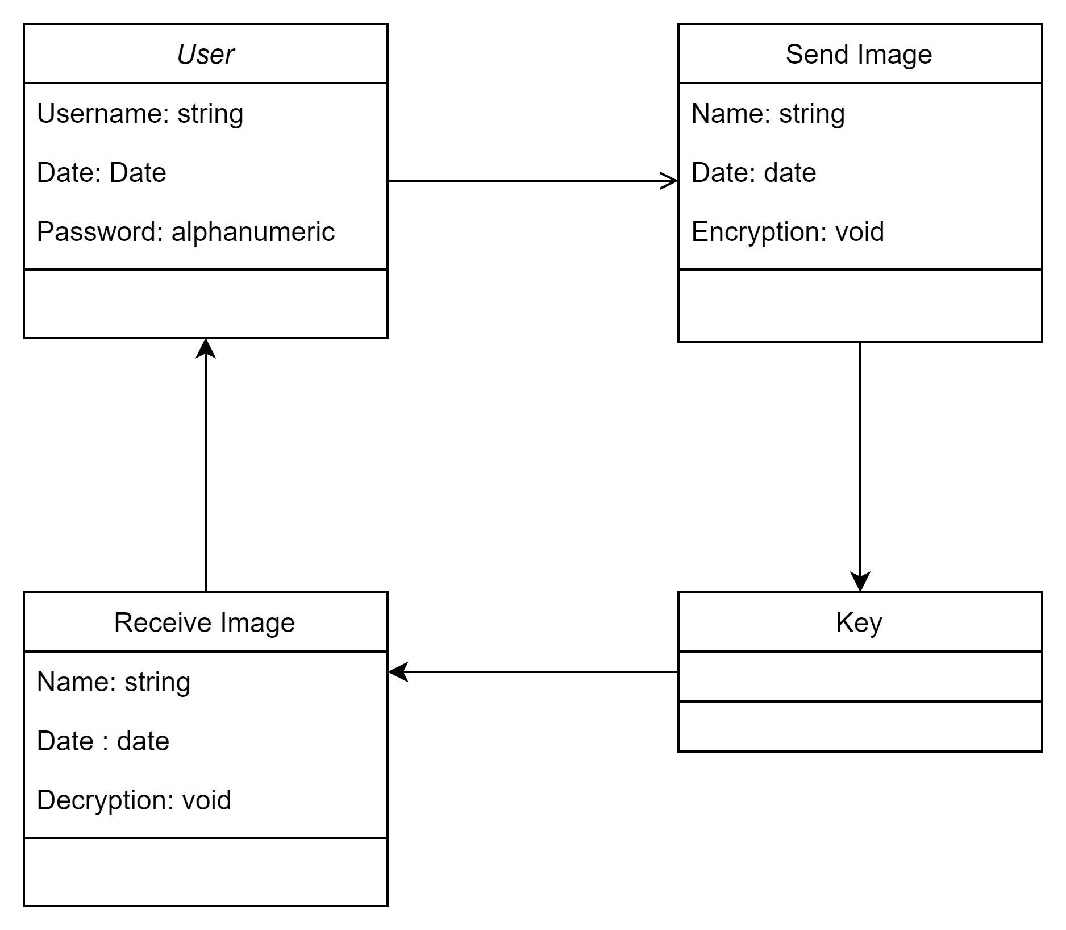

Sequence Diagram

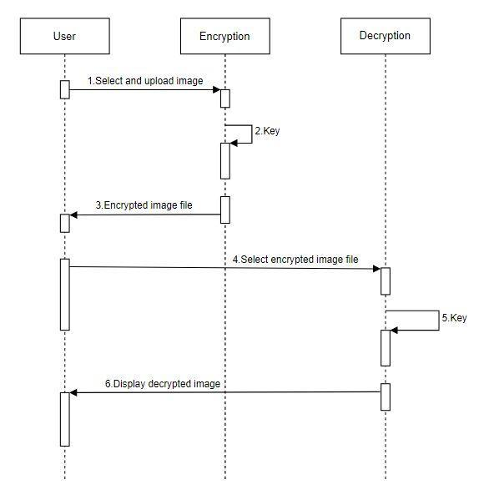

**State Chart Diagram**

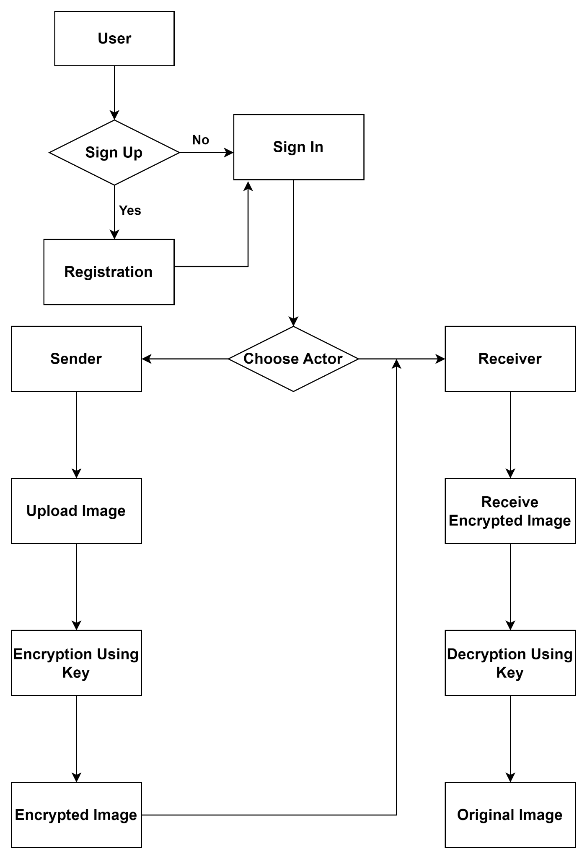

**Activity Diagram**

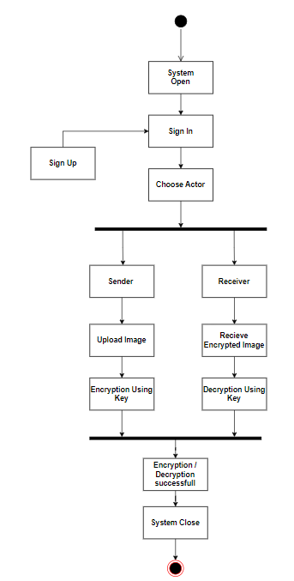

**Collaboration Diagram**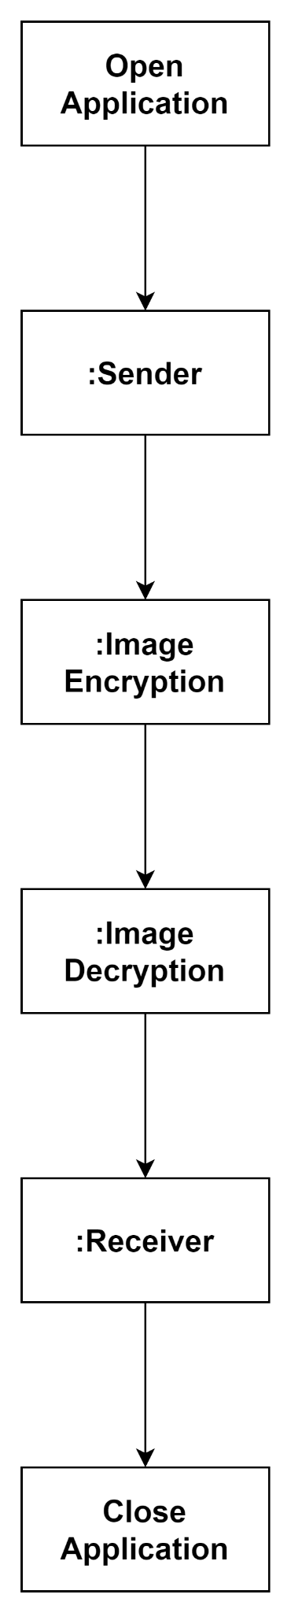

**Component Diagram**

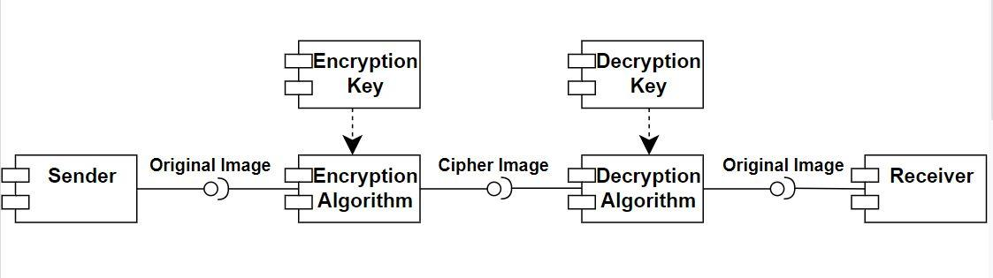

**Deployment Diagram**

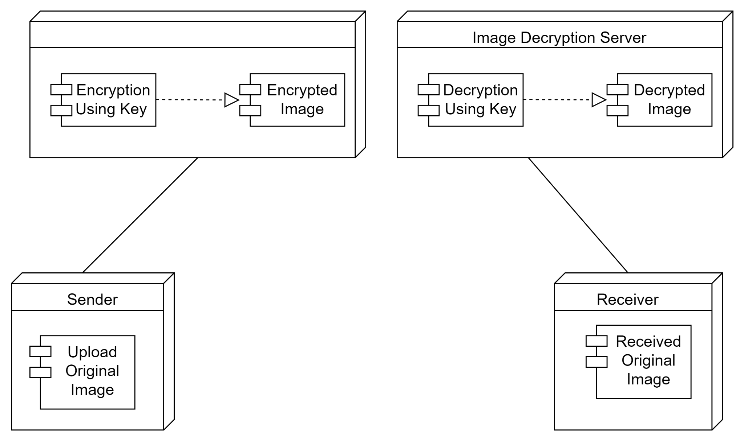

**Pros and Cons**

**Advantages:**

1. Large enough key space to resist all kinds of brute force attack

2. Cipher-image has a good statistical property

3. Encryption algorithm is sensitive to the secret keys

4. Provides high security level

5. Less computational time

6. Reliable and efficient way to deal with bulky, difficult and intractable data.

**Limitation:**

The application should be at both the sender and receiver in the network system.

Bibliography

* **Websites:**

Lucidchart

Slideshare

YouTube

Javatpoint

* **Books Referred:**

Software Engineering by Vision Publication by Dr. Reena Bharathi & Seema Purandare